For an easy understanding of this documentation, I used different colors to describe commands, comments, etc.:

- Terminal commands are red, if they depending on your personal setting I will mark them like this.
- Answers from the terminal are blue, if they depending on your personal setting I will mark them like this.
- Comments are in magenta, if they depending on your personal setting I will mark them like this.
- Lines which I have to add/change in files are green and, if they depending on your personal settings I will mark them like this.

For different Ubuntu Users, I going to use different symbols in the terminal commands:

root → #
normal user → $
oneadmin → §

!It is important that you always use the right User!

Install an Ubuntu 12.04 on my computer Username: frontend

login as root:

$ sudo su

change the /etc/apt/sources.list to the repository at the cujae:

# nano /etc/apt/sources.list

deb http://ubuntu.cujae.edu.cu/ubuntu precise-security main universe restricted multiverse
deb http://ubuntu.cujae.edu.cu/ubuntu precise-backports main universe restricted multiverse
deb http://ubuntu.cujae.edu.cu/ubuntu precise-proposed main universe restricted multiverse
deb http://ubuntu.cujae.edu.cu/ubuntu precise-updates main universe restricted multiverse
deb http://ubuntu.cujae.edu.cu/ubuntu precise main universe restricted multiverse

chance the nameserver in /etc/resolv.conf:

# nano /etc/resolv.conf

nameserver 10.8.1.70
nameserver 10.8.1.69
search cujae.edu.cu

Update the System:

# apt-get update

# apt-get upgrade

Restart the system:

# init 6

chance the nameserver in /etc/resolv.conf again because it is not saved permanently.

install the virt-manager with KVM to build a virtual machine to have a host for opennebula:

# apt-get install virt-manager kvm libvirt-bin qemu

Add the User frontend to the groups libvirtd and kvm:

# adduser <name> libvirtd (the <name> has to be my login name of the physical machine)
# adduser <name> kvm (the <name> has to be my login name of the physical machine)

Check the installation:

# virsh -c qemu:///system list

Id Name State
------------------------------

If the answer looks like this, the virtual network is reachable and the hypervisor works correct.

Starting the virt-manager to create the virtual machine which simulates the host-PC for Opennebula

# virt-manager

The virt-manager is easy to use:
- creating a virtual network on the local host
- creating the virtual machine

After creating that host we run the same steps like on the frontend:
- changing the sources.list
- changing the resolv.conf
- updating the system
- restart the virtual machine
- changing the resolv.conf again because it is not saved permantly

we are going to do the configuration of the host step by step.

Just save the host instead of shutting it down because if you save it you have no need to reconfigure the resolv.conf again.

Back on the front-end, we going to install some helpful tools:

# apt-get install mc

# apt-get install synaptic

# apt-get install sqliteman

After that we going to install the Openssh-Server/Client and configure it:

on our front-end:

- installation:

# apt-get install openssh-server

- Checking if the sshd dameon is running:

# ps -ef | grep ssh

- Configure not to ask before adding hosts to known_hosts file.
Look into ~/.ssh/config, see man ssh_config for a complete reference.

# nano /etc/ssh/ssh_config
StrictHostKeyChecking no

- Testing the connection to the local host:

# ssh localhost

The authenticity of host 'localhost (127.0.0.1)' can't be established.
ECDSA key fingerprint is 99:4c:e7:56:8e:ec:81:67:87:95:38:26:35:01:a1:e4.
Are you sure you want to continue connecting (yes/no)? yes
Warning: Permanently added 'localhost' (ECDSA) to the list of known hosts.
frontend@localhost's password:

- create an empty ssh key in the /home/username folder:

$ ssh-keygen -t rsa

~/.ssh/id_rsa : private or identification key
~/.ssh/id_rsa.pub : public key
$ cat .ssh/id_rsa.pub >> .ssh/authorized_keys2

- Login:

$ ssh localhost

- configuration of the password-less access (additional):
To disable password authentication, look for the following line in your sshd_config file:

#PasswordAuthentication yes

replace it with a line that looks like this:

PasswordAuthentication no

Explanation:
This assumes you already have successfully connected to your server via SSH. You'll need to generate an SSH Keypair which will allow you to identify you as yourself without using a password. You can opt to protect keys with a passcode if you wish, but this can be left blank allowing totally password-less SSH access. First create your SSH Keypair by running ssh-keygen this will create an id_rsa and id_rsa.pub file. The pub file is what goes on the servers, the private key (id_rsa) is what stays with you and is how you identify yourself. Next copy the public key to your server with ssh-copy-id user@server replacing user with your remote user and server with the machine DNS name or IP address. It'll prompt for your SSH password, enter it and if all completes successfully you'll be able to access the machine via ssh user@server without needing a password.

On our host:

- Install the openssh-server:

# apt-get install openssh-server

- Configure not to ask before adding hosts to known_hosts file.
Look into ~/.ssh/config, see man ssh_config for a complete reference.

# nano /etc/ssh/ssh_config
StrictHostKeyChecking no

- Create the keys in the /home/username folder:

$ ssh-keygen -t rsa

~/.ssh/id_rsa : private or identification key
~/.ssh/id_rsa.pub : public key
$ cat .ssh/id_rsa.pub >> .ssh/authorized_keys2

- Copy the keys to the Server:

$ ssh-copy-id user@server replacing user with your remote user and server with the IP address. It'll prompt for your SSH password, enter it.

- login:

$ ssh user@server replacing user with your remote user and server with the IP address.

To establish a connection in both directions do the following steps on the front-end:

- Copy the keys to the Server:

$ ssh-copy-id user@server replacing user with your remote user and server with the IP address. It'll prompt for your SSH password, enter it.

- login:

$ ssh user@server replacing user with your remote user and server with the IP address.

This key creation and exchange is necessary for every User
- on the Front-end: Oneadmin,root, User
- on the host: The user of the host

I will remember to do this settings again when we crate the oneadmin user.

How to install Open nebula 3.8.3 with KVM on the front-end:

Download open nebula version 3.8.3 Tarbell for Ubuntu 12.04 from the internet:
http://downloads.opennebula.org/
or use the downloaded file you should receive with this Documentation.
Also you receive some Gems you have to use them because the normal installation of the gems fails.
I am going to explain later how to install a Gem manually.

Unzip with mc „Ubuntu-12.04-opennebula-3.8.3.tar.gz“ to: /home/user/Desktop/Install

Change the permissions of all files:

# cd /home/user/Desktop/Install

# chmod -R 755 * (to chance the permission of all files in that folder)

The order of packages installation:

- opennebula-common: provides the user and common files
- libopennebula-ruby: all ruby libraries
- opennebula-node: prepares a node as an opennebula-node
- opennebula-sunstone: OpenNebula Sunstone Web Interface
- opennebula-tools: Command Line interface
- opennebula: OpenNebula Daemon
- libopennebula-java_3.8.3-1_all

opennebula-common:

# dpkg -i opennebula-common_3.8.3-1_all.deb

Adding group `cloud' (GID 127) ...
Done.
Adding system user `oneadmin' (UID 118) ...
Adding new user `oneadmin' (UID 118) with group `cloud' ...
Creating home directory `/var/lib/one' ...
Generating public/private rsa key pair.
Your identification has been saved in /var/lib/one/.ssh/id_rsa.
Your public key has been saved in /var/lib/one/.ssh/id_rsa.pub.
The key fingerprint is:
a8:cf:44:ce:79:09:4c:45:27:2d:82:2a:c2:05:5b:0b oneadmin@front-end
The key's randomart image is:
+--[ RSA 2048]----+
| E.. . .+.. |
| +.o ...o. |
|...o .. . |
|o.. o . |
|.. = S |
| = o . |
| . = o |
| + . |
| o |
+-----------------+

libopennebula-ruby:

# dpkg -i ruby-opennebula_3.8.3-1_all.deb

# apt-get install -f to fix the missing Parts of that installation.

opennebula-node:

# dpkg -i opennebula-node_3.8.3-1_all.deb

Adding user `oneadmin' to group `libvirtd' ...
Adding user oneadmin to group libvirtd
Done.
Adding user `oneadmin' to group `kvm' ...
Adding user oneadmin to group kvm
Done.

opennebula-sunstone:

# dpkg -i opennebula-sunstone_3.8.3-1_all.deb

# apt-get install -f to fix the missing Parts of that installation.

Error executing sunstone-server.
Check /var/log/one/sunstone.error and /var/log/one/sunstone.log for more information

This Error happens because opennebula has not been installed yet.

opennebula-tools:

# dpkg -i opennebula-tools_3.8.3-1_all.deb

opennebula:

# dpkg -i opennebula_3.8.3-1_amd64.deb

# apt-get install -f to fix the missing Parts of that installation.

Javalib:

# dpkg -i libopennebula-java_3.8.3-1_all.deb

# dpkg -i libopennebula-java-doc_3.8.3-1_all.deb

Now you have installed Open nebula 3.8.3 with Sunstone.

You have to check your Password for oneadmin go to /var/lib/one/.one and open with „F3“ the one_auth file. DO NOT CHANGE IT!

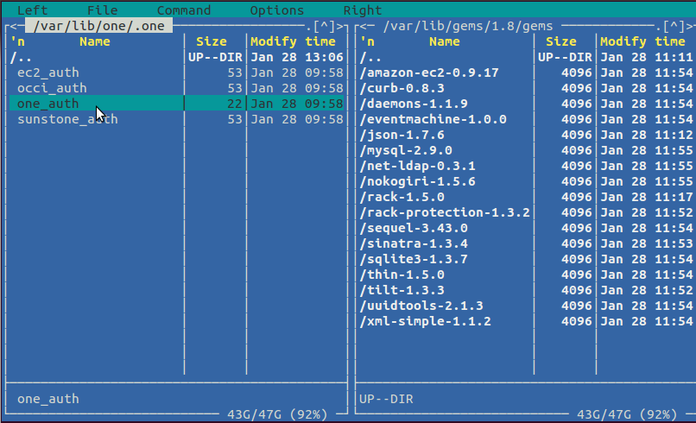
Login as Oneadmin and chance the sshkeys overwrite the old key with an empty one:

installation on the host:

ruby

# apt-get install ruby

libvirt

# apt-get install libvirt-bin libvirt-doc

kvm

# apt-get install kvm

Change the oneadmin password to abc:

# passwd oneadmin

As oneadmin connect the oneadmin to the host and frontend with ssh:

- Create the keys in the /var/lib/one folder:

§ ssh-keygen -t rsa

~/.ssh/id_rsa : private or identification key
~/.ssh/id_rsa.pub : public key
§ cat .ssh/id_rsa.pub >> .ssh/authorized_keys2

- Copy the keys to the Server:

§ ssh-copy-id user@server replacing user with your remote user and server with the IP address. It'll prompt for your SSH password, enter it.

- login:

§ ssh user@server replacing user with your remote user and server with the IP address.

Libvirt checking and configuration:

As oneadmin to check if libvirt is working correct:

§ ssh host@192.168.122.19 'virsh -c qemu:///system nodeinfo'
error: Failed to connect socket to '/var/run/libvirt/libvirt-sock': Permission denied
error: failed to connect to the hypervisor

edit file /etc/libvirt/libvirtd.conf as make following changes:

unix_sock_group = "oneadmin" [if you have given a different name for the group like "cloud" , provide that]
change the unix_sock_rw_perms = "0777"
uncomment:
unix_sock_dir = "/var/run/libvirt"

edit file /etc/libvirt/qemu.conf and make following changes:

vnc_listen = "0.0.0.0"
user = "oneadmin"
group = "cloud"
dynamic_ownership = 1
then restart libvirt as root :

# /etc/init.d/libvirt-bin restart
STILL GETTING THAT ERROR!!!!
Change the loginpw for oneadmin and sunstone:
§ echo "oneadmin:abc" > ~/.one/one_auth

a9993e364706816aba3e25717850c26c9cd0d89d the encryted abc

§ chmod 600 ~/.one/one_auth

use mc and sqliteman for change the password in /var/lib/one/oned.db for oneadmin by copying it to /home to

after that recopy it to /var/lib/one

Restart opennebula and sunstone as oneadmin:

§ /etc/init.d/opennebula restart

§ /etc/init.d/opennebula-sunstone restart

Start sunstone unsing Mozilla Firefox:

http://localhost:9869

