iSCSI-SAN OpenNebula Extension Design

(I) Component Description
- Openfiler: Openfiler is an operating system that provides file-based network-attached storage and block-based storage area network. It is free software licensed under the GNU General Public License version 2. Its software stack interfaces with open source third-party software. It supports multiple protocols like NFS, SMB/CIFS, HTTP/WebDAV, FTP, iSCSI (initiator and target). Openfiler has web based management for volume management. It is used to create Target IQNs which can be attached to VMs. The modified Openfiler will contact OpenNebula front end over XML-RPC services to make entry into OpenNebula database.
- ONE Database: Modified code of OpenNebula will generate an additional table name one_volume, which will store information about the Target IQNs. This includes IQN name, size, status, and VM id to which it is attached.
- Cluster Node: These are hypervisor-enabled host, which provide the resources needed by the Virtual Machines. They include additional component call iSCSI Initiator to request volume.
- Front End: This executes the OpenNebula and cluster services. It would contain:
- XML-PRC Service: Few more xml-rpc services would be added for communication with OpenNebula database. These services would be consumed by Openfiler and ruby based management scripts.
- Ruby Scripts: Ruby management scripts are similar to other shell script which does following functions like attach-volume, detach-volume from the domains.
- iSCSI Initiator: These are open-iscsi based initiator which would be installed on each of the nodes in the cluster. This help node to request for additional volume over the network. Open-iSCSI project is a high performance, transport independent, multi-platform implementation of RFC3720.

(II) How does it work?
Steps involved in attaching and detaching volume from instances are listed below:
- Administrator will create Target IQN of different sizes using Openfiler. To keep the process simple, let’s assume machine on which Openfiler is installed has large disk space and can allocate this space to domains over iSCSI. The IQN creation process will make an entry in ONE database over XMP-RPC service. Information corresponding to a single IQN will be stored in a single row of one_volume table. This includes IQN name, size, status, and VM id to which it is attached.
- Once IQN are created, administrator/users can attach volumes to domains using onevolume script. The command to attach will be:
- onevolume attach [options] <vm_id> <volume_size>

The execution of this script includes:
- Search one_volume table to find out unallocated IQN (status) of requisite size (volume_size). Show appropriate message to user incase of unavailability.
- If IQN is available, then find out the hostname (node) on which the stated domain is executing.
- Login the host machine to available IQN.
- Update the status of IQN in BlockStore table as unavailable.
- Use xm command to attach volume to domain.
- Show success message to user once volume is attached.

- onevolume detach [options] <vm_id> <volume_id>

The execution of this script includes:
- Prompt user with a message explaining consequences of detaching volume.
- Detach volume from the domain using xm command.
- Format the detached volume(by default, if not specified)
- Update the status of IQN as unallocated.
- Show success message to user.
Caveat:
- Shall an unallocated volume be formatted immediately?
- Can user attach an unallocated volume to other domain?

(III) Cloud UI
Attached are the snapshots of GWT based UI which will have these features available via user interface. We are in the process of building it for our internal purpose, but may make it available for the community.
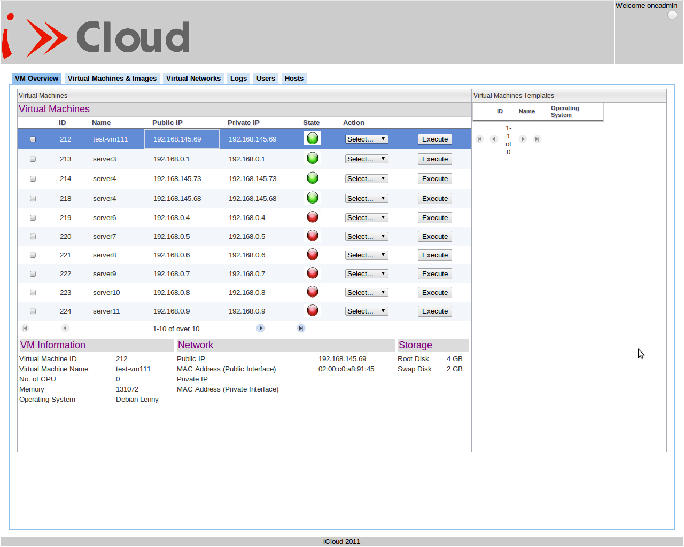

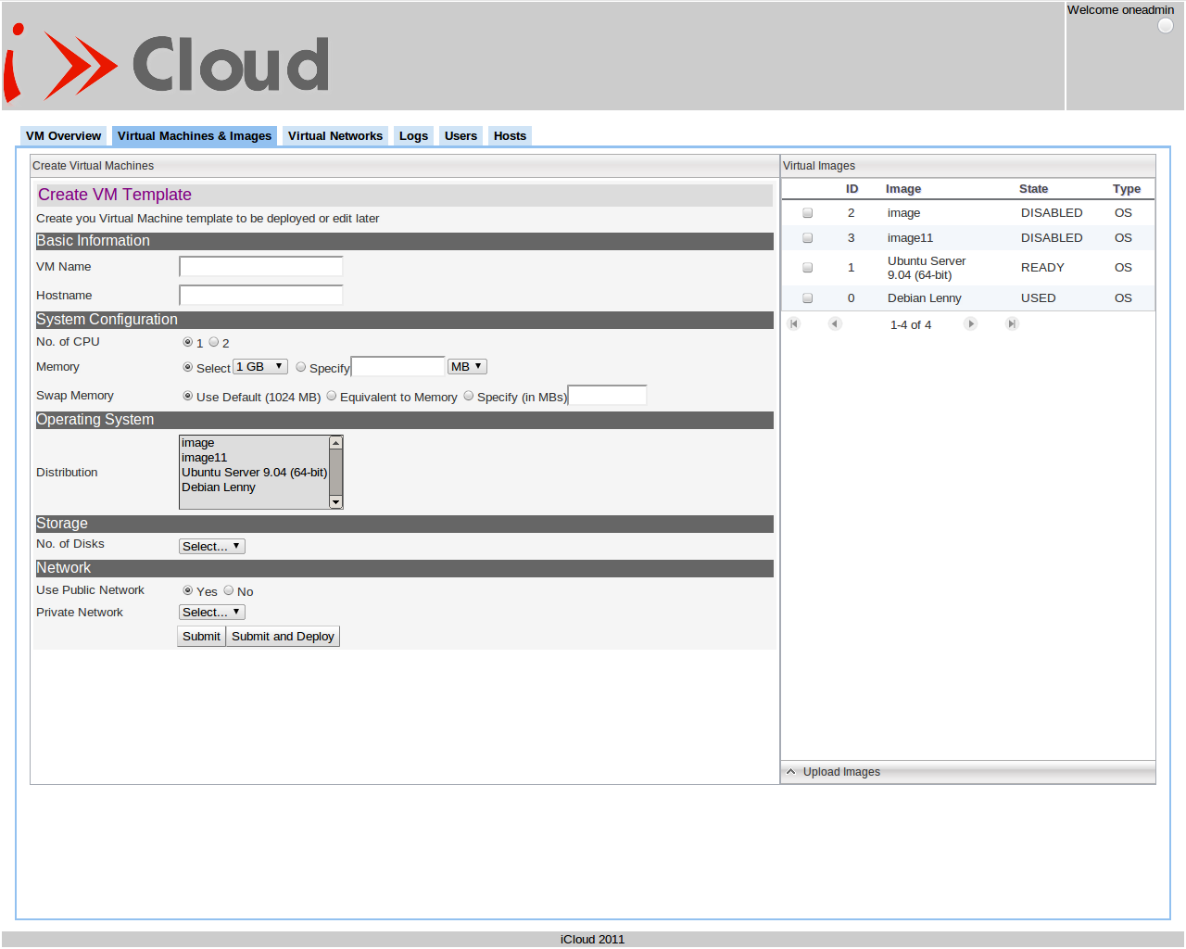

Note: We are in process of building this UI for incorporating block-store feature as well as providing the features of volume snapshot.

(IV) Packaging
- Openfiler: We have modified Openfiler to be compatible with OpenNebula. The modified Openfiler can talk with OpenNebula over XML-RPC. We plan to create a patch for Openfiler which can be installed over Openfiler and would let Openfiler to communicate with OpenNebula.
- OpenNebula: This block store OpenNebula extension can be provided as patch for now. It can be applied over the OpenNebula code base. This would include XML-RPC services and ruby scripts.
- Open iSCSI Initiator: This can be installed on nodes as specified in Open iSCSI documentation.
Note: We are not pretty sure about this packaging solution, so we would need your/community help on this.

(V) Software versions
- Xen: 4.0.1
- OpenNebula: 2.0.1
- Openfiler: 2.3
- Open iSCSI Initiator: 2.0-871

